Project based Assignment

**Project Title:** Emergency Physical Conditions Observatory System

**Submitted by:**

**Group-04**

|  |  |  |
| --- | --- | --- |
| **Section** | **Student ID** | **Student name** |
| 3 | 19101077 | Mohammad Shafkat Hasan |
| 19101669 | H.A Ibtihaz-Ul-Kabir |
| 18301217 | Nafisha Anjum |
| 17201009 | MD.Syedy Sulvy Taj |
| 17101001 | Fiona-E-Jannat |

**Course Name:** COMPUTER INTERFACING

**Course Code:** CSE360

**Semester:** Fall 2022

Submitted to: **Taufiqul Islam Khan**

BRAC University.

Date of Submission: 24 April 2022

# Table of Contents

Introduction: 2

Application Area: 2

Technology and Tools 3

Infrared (IR) Temperature Sensor: 3

BP (Blood Pressure) Sensor 3

Heart Rate Sensor 3

Pulse Oximeter 3

Arduino UNO: 3

LCD Display 3

Buzzer 4

Programming Language 4

Working Mechanism of Sensors 4

1. Temperature Sensor 4
2. BP (Blood Pressure) Sensor 5
3. Heart Rate Sensor 6
4. Pulse Oximeter 7

Connections with ICs 8

Data Flow from Sensor through ICs to I/O Devices 9

Code Implementation Idea 9

Estimated Cost Analysis 10

Responsibilities Chart: 11

Work Plan: 11

Gantt Chart: 12

Conclusion: 12

References 13

# Introduction:

We can see how technology is used in daily lives in modern environment. It will be quite difficult for us to imagine a world without technology. Almost every element of our hectic lives is influenced by technology. Aside from all the numerous uses of technology in our daily lives, we can observe an excellent use of technology in medical treatment. Every day, we face a variety of medical concerns to survive in this world, and we may need to take some emergency measurements before seeking professional help. For example, we must take accurate measurements of our body temperature, heart rate, blood pressure, oxygen saturation level and other vital signs. With the aid of technology, we can simply do it ourselves before heading to hospital as we might have to do tests like these in Hospital. In this project, we want to create an observatory system that anybody can use without any prior training, as well as professionals, and that is both pocket-friendly and simple to use. The major role of this system will be to use sensors to measure body temperature, blood pressure, and heart rate.

# Application Area:

In accordance with the project title, the implementation space of this project will be clinical instruments and medical services. The whole world is anxious over keeping up with and working on their wellbeing nonetheless sex, age, or religion. People don't have enough time, cash, or different assets to see the specialist consistently, notwithstanding the way that we really want a wellbeing test. Moreover, extreme spread of corona virus has created a restriction on going to the hospitals. We have relatives with BP (Blood Pressure) issues, respiratory issues, etc. in essentially every family. Not only this, at this time of Covid-19, we’re really in need of different health assistants among them blood oxygen saturation checking is a demand of time. Aside from gamers, different equipped and unarmed power unit individuals, like military, fireman, diver etc. require emergency pulse, blood pressure and different estimations. To resolve the above issues, we will foster the Emergency Physical Observation System as a clinical gear, which will incorporate sensors, GPIO devices and other significant innovation and instruments.

# Technology and Tools:

We'll use the Arduino UNO as an interfacing IC, an LCD display and a buzzer as IO, and infrared (IR) temperature, blood pressure, Pulse oximeter and heart rate sensors to complete this project.

A brief detail about these tools is given below:

**Infrared (IR) Temperature Sensor:** The IR temperature sensor is a type of sensor that can detect temperature without touching the human body directly. The most common applications for this sensor are to monitor the temperature of the forehead, skin, and other body parts.

**BP (Blood Pressure) Sensor:** Blood pressure is a wonderful device that utilizes non- invasive methods to assess the human body's blood pressure. It detects the pressure in the artery using a sensor. To summarize the advantages of this sensor, it is relatively safe to use due to its non-invasive nature.

**Heart Rate Sensor:** The heart rate sensor uses light reflection technology to measure heartbeats per minute. It's a simple but effective sensor that's easy to put together using Arduino. It uses an optical LED light source that shines through our skin. It determines how much light is reflected by our skin.

**Pulse Oximeter:** A Pulse Oximeter is a non-invasive device that measures the quantity of oxygen in your blood. Infrared light is sent into capillaries of patient’s finger, toe, or earlobe and calculates the amount of light reflected by the gases.

**Arduino UNO:** The Arduino UNO, as we all know, is an open-source microcontroller board with an ATmmega328p chipset. Arduino is a platform for reading and controlling data from sensors, motors, and other devices. The Arduino UNO, as well as all the sensors that will connect and operate all of the components on one board, is the most crucial component in this project.

**LCD Display:** We will use a 2 lines X 16 characters LCD module to display the data of the sensor.

**Buzzer**: Finally, we'll use a buzzer to make a beep sound while some voltages are applied.

# Programming Language:

In this project, we will use the C programming language to accomplish our goal in Arduino UNO. Here we will Arduino IDE for doing our programming for this project.

# Working Mechanism of Sensors:

The project is intended for medical purposes, with the primary goal of measuring various parameters such as temperature, heart rate, and blood pressure in a convenient manner.

The sensors we used for each parameter are listed below.

## Temperature Sensor:

First, we must define a temperature sensor. It is a device (electronic or analog) that can measure the temperature of its surroundings (or body) and convert the temperature into input data, which is then converted into electronic data to record, signal, and sometimes even monitor temperature changes.

Some temperature sensors (among many others) require direct contact with a physical object (body in our case) to be monitored (e.g., contact temperature sensors), whereas others can calculate the temperature of an object directly (e.g., non-contact temperature sensors). These are used in the measurement of patient body temperature during MRI, fMRI also other specialized electro-surgical procedures and many more purposes.

In our project, an infrared sensor is utilized to measure the temperature of a body in our research. For years, infrared (IR) technology has been employed for continuous temperature measurement and control with great success. In order to improve the accuracy, dependability, and ease-of-use of IR solutions in more demanding and emergency medical scenarios, we employed the new design.

Based on the fundamental principles of infrared devices, we can conclude that every object emits radiant energy, the intensity of which varies with temperature. The sensors simply

measure the strength of each radiation, which is equivalent to sensing an object's temperature. To be clear, infrared thermometers can be compared to human vision. Radiation (photon flow) from the object travels through the environment to the photosensitive layer (retina), where the lens of the eye is analogous to optics. After the temperature change is compensated for, it is converted to a signal and sent to the brain (here, the controller). The temperature of the object usually determines the intensity of this movement (monitored). Because molecular mobility represents charge displacement, electromagnetic radiation (mostly photon particles) is emitted. These photons normally travel at the same speed as light and obey all the previously mentioned optical laws. They can be focused by using a lens, reflected by using reflective surfaces, or deflected by using reflective surfaces. The infrared sensor arrangement now allows temperature measurement from a significant distance without touching the monitored object.

The below are some of the benefits of employing non-contact IR temperature measurement:

* Higher throughput
* Reduced energy costs
* Less downtime
* Higher quality products
* Improved maintenance
* Easy data recording

The infrared sensors used in our project have the potential to advance temperature measurement in the field of medical science. Finally, the data can be controlled in a closed-loop system with simultaneous analog and digital output, enabling remote temperature monitoring and analysis.

## BP (Blood Pressure) Sensor:

BP or blood pressure is one of the critical indicators for our project. It is primarily caused by the pressure exerted on the artery walls by the circulating blood of the entire body. The most common way to express blood pressure is the systolic to diastolic pressure ratio. A mercury sphygmomanometer is used to take blood pressure readings. Although there are several methods for measuring blood pressure, the auscultatory method with a mercury sphygmomanometer is considered the "gold standard" for office blood pressure monitoring.

As technology advances, devices for assessing vital signs using a non-invasive optical measurement technique are being developed as technology progresses; one such gadget is the

blood pressure sensor. To measure human blood pressure, we employed a non-invasive blood pressure sensor. It primarily uses the 'gold standard' Oscillometric technique to measure systolic, diastolic, and mean arterial pressure. The pulse rate is also visible. As a result, the sensor is non-invasive and safe to use. Not only does the sensor calculate pressure and monitor mercury levels, but it also simplifies the procedure by providing auto results.

It includes some important components such as:

* Vernier BP Sensor
* Adult size adjustable cuff (30 cm to 44 cm)
* Bulb pump (with release valve)

The basic premise of a Blood Pressure Sensor is that it measures blood pressure using a cuff (pressure cuff) connected to a mercury column.

To increase or decrease the pressure on an artery, the user pumps the cuff with his hand. A stethoscope is then used to listen to the sound of blood flowing through the artery.

For this project, we employed an automated BP monitor. Instead of mercury, a pressure sensor is utilized in the automatic Blood Pressure measurement system to collect data and determine artery pressure. As a consequence, you'll have a digital file. On the monitor, this output is presented. Furthermore, the monitor has an embedded CPU that processes any pressure sensor output, records the information, and displays it on the digital screen. This sensor is critical for persons with high blood pressure because it is portable and may be used as a solid-state Blood Pressure Monitor anyplace. A major component of this device is the pressure sensor in the cuff. The pressure sensor should be carefully chosen for precise and dependable measurement.

## Heart Rate Sensor:

A heart rate sensor is an electronic device that measures the speed of the heartbeat or heart rate. In our project, we used a BP sensor, which allows us to measure patients' blood pressure as well as perform other tasks, whereas a heart rate sensor only measures the specific heart rate. Because of heart problems, some patients must have their heart rate monitored on a daily basis, which can be costly. As a result, this sensor was created specifically for that group of people. It can come in a variety of shapes and sizes.

In this project, we basically created a Heart Rate Monitor System with Arduino and a Heartbeat Sensor as major sensors in this project. Smart watches, smart phones, chest straps, and other devices all have heartbeat sensors. Bpm (beats per minute) is a unit of measurement for heartbeat (the number of times the heart beats in one minute).

Heart rate monitoring is essential for both athletes and patients. Why? Because it determines one's emotional state (by reading just the heart rate). Heart rate can be measured in a variety of ways, the most convenient of which is to use a Heartbeat Sensor.

The pulse waves are measured by the optical heart rate sensor (changes in the volume of blood vessels that occurs when the heart is pumping blood). Measurement of volume changes is widely used to detect pulse waves, necessitating the usage of an optical sensor as well as a green LED. To detect pulses in the sensor block, we utilize an optical filter designed wave, which reduces the impacts of ambient light (e.g., red and infrared rays). This will allow for the capture of high-quality pulse signals as well as working outside. Furthermore, ROHM (semiconductor) was able to steadily increase the sensitivity of the sensor block by utilizing optical sensor technology that had been developed over a long period of time. Support for lower-brightness low-VF LEDs enables the development of a low-power optical heartbeat monitoring system that does not require any additional equipment (for example, boost circuit). This enables watches and other wearable techs with limited battery capacity to run for longer periods of time.

1. **Pulse Oximeter**: The Coronavirus Disease 2019 (COVID-19) pandemic has caused an expansion in the utilization of heartbeat oximeters. Pulse oximeter is utilized to quantify the degree of (oxygen immersion) in the blood. It's a straightforward, easy proportion of how well oxygen is being conveyed from your heart to parts of your body, like your arms and legs. It tends to be utilized to check assuming there is sufficient oxygen in the blood and to check the strength of an individual with any condition that influences blood oxygen levels. High physiological pressure and high heights can be a justification for changing degrees of oxygen. The human body is for the most part equipped for adjusting to such outrageous conditions however hypoxemia is consistently a chance.

A heartbeat oximeter is a gadget that is normally positioned on a fingertip. It utilizes light bars to assess the oxygen immersion of the blood and the beat rate. Oxygen immersion gives data

about how much oxygen conveyed in the blood. The beat oximeter can assess how much oxygen in the blood without drawing a blood test.

Most heartbeat oximeters show a few numbers. The main number, oxygen immersion level, is typically curtailed SpO2, and is introduced as a rate. The beat rate (like pulse) is abridged PR, and in some cases, there is a third number for strength of the sign.

# Connections with ICs:

## Arduino UNO:

First of all, we must power on the Arduino board. So, we'll power up the Arduino UNO board with a 12-volt DC battery via the Arduino's power port. To achieve our goal, we will upload the code via the USB port. In the Code explanation section, the required code for the aimed project will be explained. The other connection with the Arduino, sensors, and IO is described further below.

## IR Temperature Sensor:

Connecting the GND of the sensor with the Arduino GND. Power consumption will be through the 5V pin of the Arduino. Two output pins will be connected to A4 and A5 of the Arduino.

## BP Sensor:

The GND and VCC of the sensor will be connected to the GND pin and 5V pin of the Arduino UNO. The output pin V0 will be connected to the A2 pin of the Arduino.

## Heart Rate Sensor:

VCC and GND will be connected to 5V and GND pin of the Arduino. Output Pin of the sensor will be connected to the A0 of the Arduino.

## Pulse Oximeter:

VCC and GND will be connected to 5V and GND pin of the Arduino. Output Pin of the sensor will be connected to the A1 of the Arduino.

## LCD:

The +5 VCC and GND pin of the 2X16 LCD will be connected to the 5V pin and GND pin of the Arduino. Anode (LED+) and cathode (LED-) pins of the LCD will be connected to 5V and GND of the Arduino. Data pin of the LCD D4 - D7 will be connected to D5 - D2 pin of the Arduino to use half byte mode. RS pin of the LCD will be connected to D12 pin of the Arduino. EN pin will be connected to Arduino’s D11 pin. RW pin of the LCD will be grounded through

Arduino’s GND. If we want, we can use a regulator switch to control the brightness of the LCD.

## Buzzer:

Black wire connection with the GND of Arduino and red wire of the buzzer will be connected to D8 of the Arduino.

# Data Flow from Sensor through ICs to I/O Devices:

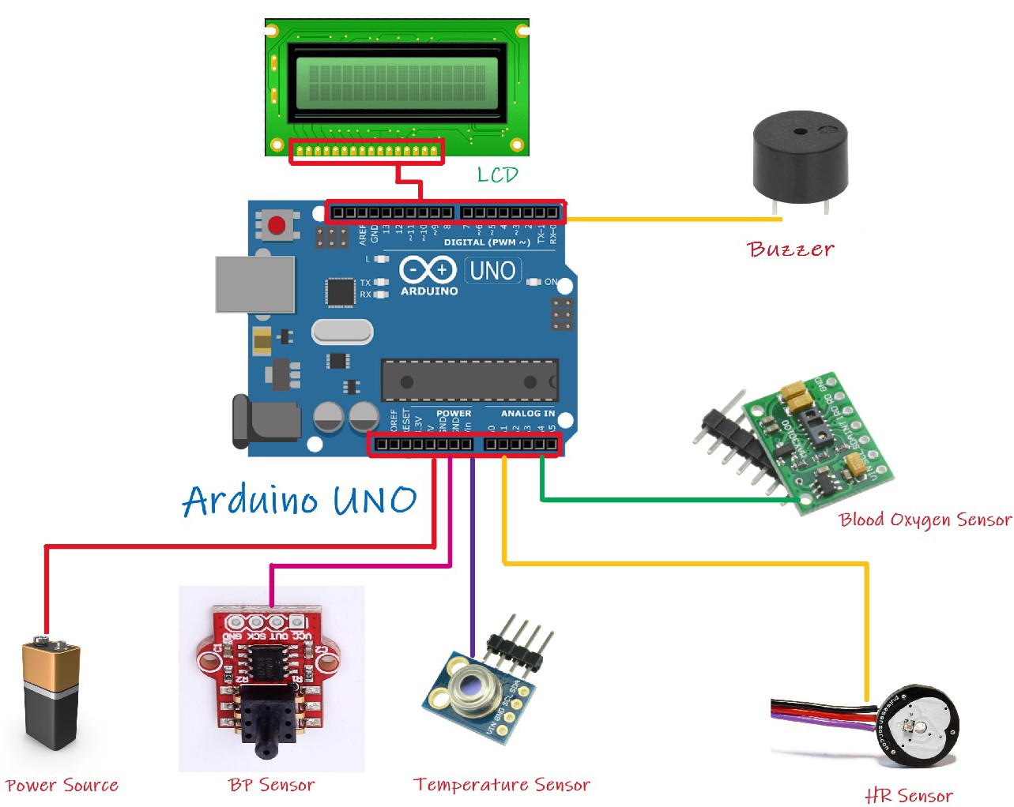

*Figure: Data Flow Diagram and Connections of the circuit.*

# Code Implementation Idea:

First of all, we will include all the necessary library in the IDE. We will initialize some variables with a view to store the data taken from the sensors. Then we will implement a void setup() method where pinmode() will be set up such that input will be IR temp sensor, BP sensor, Pulse Oxemeter and Heart Rate sensor. Along with this, pinmode() will take LCD as output. There will be a void loop() method which will be showing the data to the LCD received

from the sensor. If-else condition will be implemented to check whether variables responsible for different sensors have 0 or any other value. After every iteration, the value of the respective variable will be set to 0. While checking each variable, if there is any one variable with value greater than 0 will be shown in the LCD.

# Estimated Cost Analysis:

The following are the ingredients needed to produce an Urgent Healthcare Solution, along with their costs:

|  |  |  |
| --- | --- | --- |
| **Components** | **Quantity** | **Estimated Cost (tk)** |
| **Pulse Oximeter (MAX30100)** | 1 | 298 |
| **IR Temperature Sensor**  **(GY906)** | 1 | 1150 |
| **Blood Pressure Sensor**  **(XGZP6847)** | 1 | 400 |
| **Heart Rate Sensor**  **(MAX30102)** | 1 | 200 |
| **Arduino Uno R3** | 1 | 549 |
| **16*2 LCD Display** | 1 | 100 |
| **Battery** | 1 | 35 |
| **Jumper Wires (Male to**  **Female)** | 20 | 80 |
| **Jumper Wires (Male to male)** | 20 | 80 |
| **Buzzer** | 1 | 15 |
| **Total** | 48 | 3000  (Approximately) |

# Responsibilities Chart:

|  |  |  |
| --- | --- | --- |
| **Responsibilities** | **IDs** | **Name** |
| Writing Technologies and Tools, Working  Mechanism of Sensors, Reference. | 18101321 | Nazmul Islam |
| Work Plan part, Estimated Cost Analysis,  Responsibilities of Each, Reference. | 18101147 | SM Mohtasim Billah Fahim |
| Data Flow (full figure), Programming Language Part, Connection with ICs, Code Implementation Idea, Reference. | 18101142 | Shovon Mandal |
| Writing Introduction, Application Area,  Conclusion part, Reference. | 18101092 | Syeda Nowrin Reza |
| Discussion, Research, Topic Choosing,  Work Plan and Gantt Chart. | All | Members |

# Work Plan:

|  |  |  |  |
| --- | --- | --- | --- |
| **Work** | **Start Date** | **End Date** | **Duration** |
| Group Making | 02-04-22 | 04-04-22 | 4 |
| Topic Selection | 21-12-21 | 23-12-21 | 2 |
| Discussion | 24-12-21 | 30-12-21 | 6 |
| Research | 26-12-21 | 10-01-22 | 15 |
| Work Distribution | 11-01-22 | 14-01-22 | 3 |
| Buying Components | 15-01-22 | 22-01-22 | 7 |
| Hardware Setup | 22-01-22 | 27-01-22 | 5 |
| Software Implement | 28-01-22 | 05-02-22 | 8 |
| Testing and Debugging | 06-02-22 | 20-02-22 | 14 |
| Writing Report | 20-02-22 | 25-02-22 | 5 |
| Final Discussion | 25-02-22 | 27-02-22 | 2 |
| Submission | 27-02-22 | 28-02-22 | 1 |

# Gantt Chart:



**Gantt Chart**

16-12-21 26-12-21 05-01-22 15-01-22 25-01-22 04-02-22 14-02-22 24-02-22 06-03-22

Group Making Topic Selection

Discussion Research

Work Distribution Buying Components Hardware Setup Software Implement Testing and Debugging

Writing Report Final Discussion Submission

*Figure: Gantt Chart*

# Conclusion:

In this period of progressive innovation, we, human is distracted with the survival of the fittest. Nonetheless, we don't have the opportunity to actually look at our wellbeing. Our ideal innovation can possibly have a huge effect in the existences of the individuals who are immensely occupied while keeping their ordinary everyday practice. Besides that, relatives in our family who have hypertension and serious heart issues will want to deal with their own wellbeing because of our designated exertion. To sum up, those with ailments as well as individuals in different callings like instructors, armed and unarmed powers units, lenders, and even specialists will indeed be able to benefit incredibly from this fundamental innovation.

# References:

Agarwal, T. (2019, October 9). *Blood Pressure Sensor - Working and It’s Applications*.

ElProCus - Electronic Projects for Engineering Students. <https://www.elprocus.com/blood-pressure-sensor-working-applications/>

*DIY Heart Rate Sensor*. (n.d.). Arduino Project Hub. <https://create.arduino.cc/projecthub/Ingeimaks/diy-heart-rate-sensor-a96e89>

*Infrared Thermometer with Arduino and MLX90614 Temperature Sensor*. (2019, October 28). Electronics-Lab.Com. https[://w](http://www.electronics-lab.com/project/infrared-)ww.[electronics-lab.com/project/infrared-](http://www.electronics-lab.com/project/infrared-)

thermometer-arduino-mlx90614-temperature-

sensor/#:%7E:text=The%20MLX90614%20is%20an%20infrared,Small%20size%20a

nd%20low%20cost

*Measure SpO2, Heart Rate and BP Trends (BPT) Using Arduino*. (n.d.). Arduino Project Hub. [https://create.arduino.cc/projecthub/protocentral/measure-spo2-heart-rate-and-](https://create.arduino.cc/projecthub/protocentral/measure-spo2-heart-rate-and-bp-trends-bpt-using-arduino-bcc316)

[bp-trends-bpt-using-arduino-bcc316](https://create.arduino.cc/projecthub/protocentral/measure-spo2-heart-rate-and-bp-trends-bpt-using-arduino-bcc316)

*NCBI - WWW Error Blocked Diagnostic*. (n.d.). Principles and Techniques of Blood Pressure Measurement. <https://www.ncbi.nlm.nih.gov/pmc/articles/PMC3639494>/

*Tele-Presence Robot for Medical Assistance in Hospitals*. (n.d.). NASA/ADS. [https://ui.adsabs.harvard.edu/abs/2021JPhCS1916a2096S/abstract?fbclid=IwAR1T6O](https://ui.adsabs.harvard.edu/abs/2021JPhCS1916a2096S/abstract?fbclid=IwAR1T6ObIVl5ievp_c9EzO5FP6_K1X9_4itAzUn0OpBZzC5fH1ni5r_B80_c)

[bIVl5ievp_c9EzO5FP6_K1X9_4itAzUn0OpBZzC5fH1ni5r_B80_c](https://ui.adsabs.harvard.edu/abs/2021JPhCS1916a2096S/abstract?fbclid=IwAR1T6ObIVl5ievp_c9EzO5FP6_K1X9_4itAzUn0OpBZzC5fH1ni5r_B80_c)